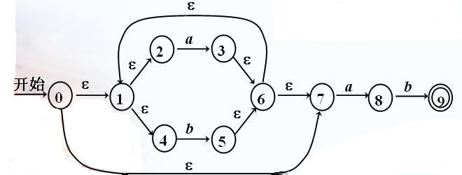

1．分别求ε-closure
ε-closure(0) = {0,1,2,4,7}
ε-closure(1) = {1,2,4}
ε-closure(2) = {2}
ε-closure(3) = {1,2,3,4,6,7}
ε-closure(4) = {4}
ε-closure(5) = {1,2,4,5,6,7}
ε-closure(6) = {1,2,4,6,7}
ε-closure(7) = {7}
ε-closure(8) = {8}
ε-closure(9) = {9}

2．转换算法：
ε-closure(0) = {0,1,2,4,7} = A
ε-closure(move(A,a))=ε-closure({3,8})={1,2,3,4,6,7,8} = B
ε-closure(move(A,b))=ε-closure({5})={1,2,4,5,6,7} = C
ε-closure(move(B,a))=ε-closure({3,8}) = B
ε-closure(move(B,b))=ε-closure({5,9})={1,2,4,5,6,7,9} = D
ε-closure(move(C,a))=ε-closure({3,8}) = B
ε-closure(move(C,b))=ε-closure({5}) = C
ε-closure(move(D,a))=ε-closure({3,8}) = B
ε-closure(move(D,b))=ε-closure({5}) = C

3．状态转换图
状态集合D中含有NFA中的接受状态9，因此D为接受状态。
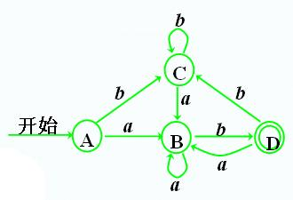

注意：如果状态转换图中不含有ε，则无需求ε-closure，直接将NFA的开始状态集合作为DFA的开始状态，对于字母表中的字符进行标记即可。

